Imaging Referral Form
Dental Cone Beam CT Imaging Referral Form for Cygnet House Dental Studio
PRIVATE / NHS (please delete as necessary)
Patient Details Male / Female
Name: Date of Birth:
Address:

Patient contact Tel: H: M: Pregnant: Y / N
Referrer Details
Name:
Address:
Signature:
Date of referral:
Referrer contact Tel: Email:
The clinical context for requesting a dental CBCT examination

Relevant results of history, clinical examination and other imaging

What information do you want the dental CBCT examination to provide?

Define the anatomical area that the scan(s) should cover

Justification: (completed by Cygnet House Dental Studio)
Name of IRMER practitioner:
Signature:
Date:
Details of scan authorised:

Scan information: (completed by Cygnet House Dental Studio)
Name of Operator:
Signature:
Date of scan:
Exposure factors used:

Clinical evaluation (Reporting)*
Name of Operator (Reporting):
Signature:
Date:
Outcome:

*If, under the Service Level Agreement dental CBCT images will be reported on by the referring practice, this fact should be recorded here. The referring practice will then be responsible for ensuring the clinical evaluation takes place and is properly recorded.
ON COMPLETION, RETAIN THIS FORM AND RETURN A COPY TO REFERRING PRACTICE

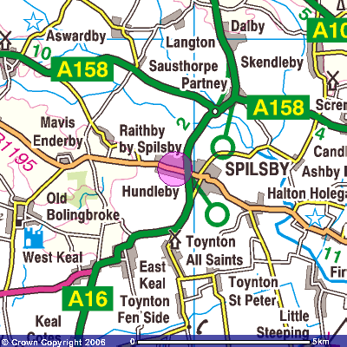
How to find us:
Cygnet House Dental Studio is the 2nd Left after you have turned off the A16 onto the B1195 (Hundleby Road). Turn left at the Hundleby Sign into Grace Swan Close. Our building is the main detached building at the BACK of the car park.
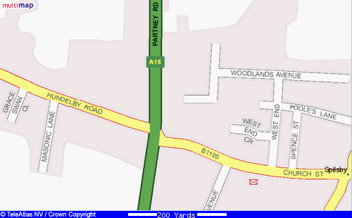 Appointment Service Only.
We are here
Access to our dedicated radiography suite is via stairs. Please allow 20 minutes for your examination. We accept all major credit cards, cheques and cash.
Standard Terms & Conditions:
Cygnet House Dental Studio Ltd aim at assisting professionals and patients in diagnosis and treatment planning. Cygnet House is not providing and is not responsible for providing any interpretation of images. Radiology reports can be ordered through Cygnet House; they are provided under radiologist’s professional responsibility, not under the responsibility of Cygnet House at an additional cost to the patient.
Cygnet House endeavours to provide the very highest quality results, however Cygnet House will not accept any liability for incorrect or incomplete information on the referral form or inappropriate or inadequate patient preparation which may compromise the value of the final results. By referring a patient, the referring practitioner agrees to the terms of the Cygnet House standard Service Level Agreement.
Cygnet House endeavours to despatch the images to the referrer and /or the patient as quickly as possible, however e.g. equipment malfunction may introduce delays. Cygnet House reserves the right not to accept referrals in such cases. Also, Cygnet House cannot guarantee when radiology reports will be available to the referrers as this is a service that we outsource.
*To be completed by the patient on the day of visit:
Patients paying for the services that Cygnet House provides will have been given information regarding prices prior to the treatment and they will need to settle their accounts on the day of the visit. If not, delay in the processing of the order or the delivery of the complete service may occur.
I confirm that I have read and understood the terms and conditions above.
Name-______________________________ Date__________________ Signature________________________

